FLOODSENSE: AN ANDROID-BASED EXPERT SYSTEM FOR FLOOD SUSCEPTIBILITY ASSESSMENT AND PRE-EVENT PREPAREDNESS IN BACOOR CITY

Undergraduate Thesis
Submitted to the Faculty of the
Department of Computer Studies
Cavite State University - Bacoor City Campus
City of Bacoor, Cavite

In partial fulfillment of the
requirements for the degree
Bachelor of Science in Computer Science

REYMART V. GOC-ONG
MARTIN LORENZ D. JUANITES
ROMAR T. PULAO
May 2027
FloodSense: An Android-Based Expert System for Flood Susceptibility Assessment and Pre-Event Preparedness in Bacoor City

Reymart V. Goc-ong
Martin Lorenz D. Juanites
Romar T. Pulao

An undergraduate thesis manuscript submitted to the faculty of the Department of Computer Studies, Cavite State University - Bacoor City Campus, City of Bacoor, Cavite, in partial fulfillment of the requirements for the degree of Bachelor of Science in Computer Science with Contribution No. _____________. Prepared under the supervision of

INTRODUCTION
The first decisions about a flood are often made before floodwater is visible. A household may protect belongings, change a planned trip, or make arrangements for someone who may need help leaving home. These choices depend on how people understand weather information and the places where they live and move. Preparedness thus begins before an emergency response, when there is still time to consider protective action.
Flood conditions are not uniform across a city. Rainfall interacts with elevation, drainage, land cover, and river systems, so a broad weather update cannot describe the same conditions at every location. A Philippine GIS study used several geographic factors to map flash-flood susceptibility within one barangay, illustrating the importance of local context (Puno et al., 2022). A susceptibility map, a rainfall bulletin, and an official warning also communicate different kinds of information. Their distinctions matter when people interpret what they see before a possible flood.
In the Philippines, flood-related information carries different levels of public authority. The Philippine Atmospheric, Geophysical and Astronomical Services Administration issues official hydro-meteorological information, while national and local disaster-management bodies coordinate action under established response arrangements (National Disaster Risk Reduction and Management Council [NDRRMC], 2024). Information used to consider possible conditions before an event is different from an official forecast, warning, or evacuation instruction. Keeping these roles distinct helps readers understand the purpose and authority of each message.
Bacoor City offers a concrete local setting for examining preparedness. The Japan International Cooperation Agency (JICA, 2021) reported completion of the Imus River Basin subproject, including retarding basins in Bacoor and Imus intended to reduce peak floodwater volume in low-lying Cavite areas. These structures show that flood management in the locality involves river behavior, built infrastructure, and cooperation among public institutions. They also place residents' preparations within a wider setting of public works and local disaster management.
Against this background, the meaning and limits of flood information deserve careful attention. Residents may encounter weather bulletins, barangay announcements, maps, and preparedness guidance as they make decisions before heavy rainfall. Each resource has a different source and purpose, and its relevance depends partly on the location and decision at hand. Examining residents' experiences together with available institutional records provides a grounded basis for the study's research questions.
Statement of the Problem
Bacoor residents obtain flood-related information through public advisories, barangay announcements, online sources, and personal contacts. These sources do not necessarily answer the same location-specific or preparedness questions. In the initial purposive survey of 40 eligible adults from 14 Bacoor barangays, 29 respondents (72.5%) described obtaining needed flood information as difficult, very difficult, or usually impossible. This finding describes the participating group, not the prevalence of the problem across the city. What flood-information problems and preparedness needs are evident among the participating Bacoor residents?
Flood experiences can disrupt household activities and affect decisions about protection and movement. Among the 40 respondents, 30 (75.0%) said that inadequate information often or always affected their decisions during flooding. The response indicates that information access matters to the surveyed residents, although it does not establish the effectiveness of any proposed application. What flood experiences, information-access difficulties, and preparedness needs are reported by the participating Bacoor residents?
Understanding conditions at a particular place and finding dependable evacuation information are distinct tasks. Thirty respondents (75.0%) found it difficult, very difficult, or did not know how to determine their location's flood susceptibility, while 33 (82.5%) found verified evacuation-center information difficult to locate or did not know where to find it. Institutional records also require attention to source ownership, authorization, and geographic validation. What geographic, knowledge, preparedness, privacy, provenance, and administrative requirements can be established from the resident, interview, and documentary evidence?
Most survey participants could access an Android device: 34 owned one and five shared one. However, reliable internet access was not universal, and the participants' technology conditions alone do not determine a suitable assessment design. The study must organize the documented needs without treating hypothetical scenarios as live observations or unverified geographic records as official hazard data. How can the established requirements be developed into a resident-requested, pre-event assessment and a distinct preparedness-support process with appropriate administrative controls?
A developed application cannot be regarded as technically dependable merely because its screens and records exist. Its resident, geographic, assessment, guidance, and administrative functions must be checked against defined behaviors and data boundaries. To what extent do these functions operate correctly and consistently under specified technical test cases?
Technical verification does not by itself establish how intended users and evaluators perceive the system's quality. A separate evaluation must use an approved instrument and defined evaluator groups; initial needs-survey responses cannot substitute for post-use findings. How will the relevant ISO/IEC 25010 product-quality characteristics of the completed system be evaluated?
Objectives of the Study
Generally, the study seeks to develop and evaluate FloodSense as a scenario-based Android system for explainable flood-susceptibility assessment and separate pre-event preparedness support in Bacoor City.
Specifically, it seeks to:
1. identify the flood experiences, information-access difficulties, preparedness needs, and technology conditions reported by eligible Bacoor City respondents;
2. determine the geographic, knowledge, rainfall-scenario, privacy, provenance, preparedness, and administrative requirements supported by resident, interview, and documentary evidence;
3. develop FloodSense as a Flutter-based Android resident application and Django-based Web Administration System through Evolutionary Prototyping, with these major functions:
• authenticated resident and authorized-administrator access with role-based permissions and privacy controls;
• user-confirmed rainfall scenario and location inputs, including barangay selection, manual map pin, and optional foreground location;
• deterministic susceptibility assessment, explanation, and geographic presentation;
• separate preparedness guidance and evacuation-center reference information; and
• controlled administration of geographic references, parameters, guidance, sources, and review records;
4. test the resident, administrative, geographic, Expert System, and Decision Support System functions through applicable unit, integration, API, spatial, and end-to-end tests; and
5. evaluate selected product-quality characteristics of FloodSense using an approved ISO/IEC 25010-based instrument.
Theoretical Framework
The theoretical framework of FloodSense connects resident access, user-confirmed inputs, deterministic inference, geographic presentation, separate preparedness guidance, and governed information management. Consistent with the study's research problems, related functions are consolidated under five function-named modules rather than being separated according to individual technologies.
User Access and Authentication Module. This module controls resident and administrator identity, registration, sign-in, verification, password recovery, privacy and legal acceptance, profiles, roles, and permissions. Authentication is necessary because FloodSense processes account information, optional location data, and governed administrative records that must not be available to unauthorized users.
Scenario and Location Input Module. This module receives the resident's hypothetical rainfall intensity and duration and the selected location. The resident may choose a barangay, adjust a temporary map pin, or request one-time foreground location access, then confirm or correct the resolved barangay before requesting assessment. These inputs describe a user-selected scenario rather than a live observation or forecast.
Susceptibility Assessment and Explanation Module. This module validates the confirmed facts, applies deterministic rule matching and conflict handling, and returns a susceptibility class with a human-readable explanation and geographic presentation. The same approved facts and rule version produce the same outcome, while the scientific and local validity of the underlying knowledge remains dependent on appropriate data, provenance, expert review, and institutional authorization.
Preparedness Decision Support Module. This module presents source-backed preparedness guidance through structured questions and information flows. It also displays evacuation-center reference records and a straight-line nearest-center ranking when suitable records are available. The guidance remains separate from the susceptibility assessment and does not modify the assessment class or issue an evacuation order.
Administration and Data Governance Module. This module supports authenticated and permission-controlled management of rainfall and map references, assessment parameters, DSS content, evacuation-center records, data sources, review records, and audit history. Ordinary administrators do not directly modify raw rule conditions, priorities, conflict-resolution logic, or algorithm code. Technical Django Admin access remains separate and is reserved for developer or research maintenance.
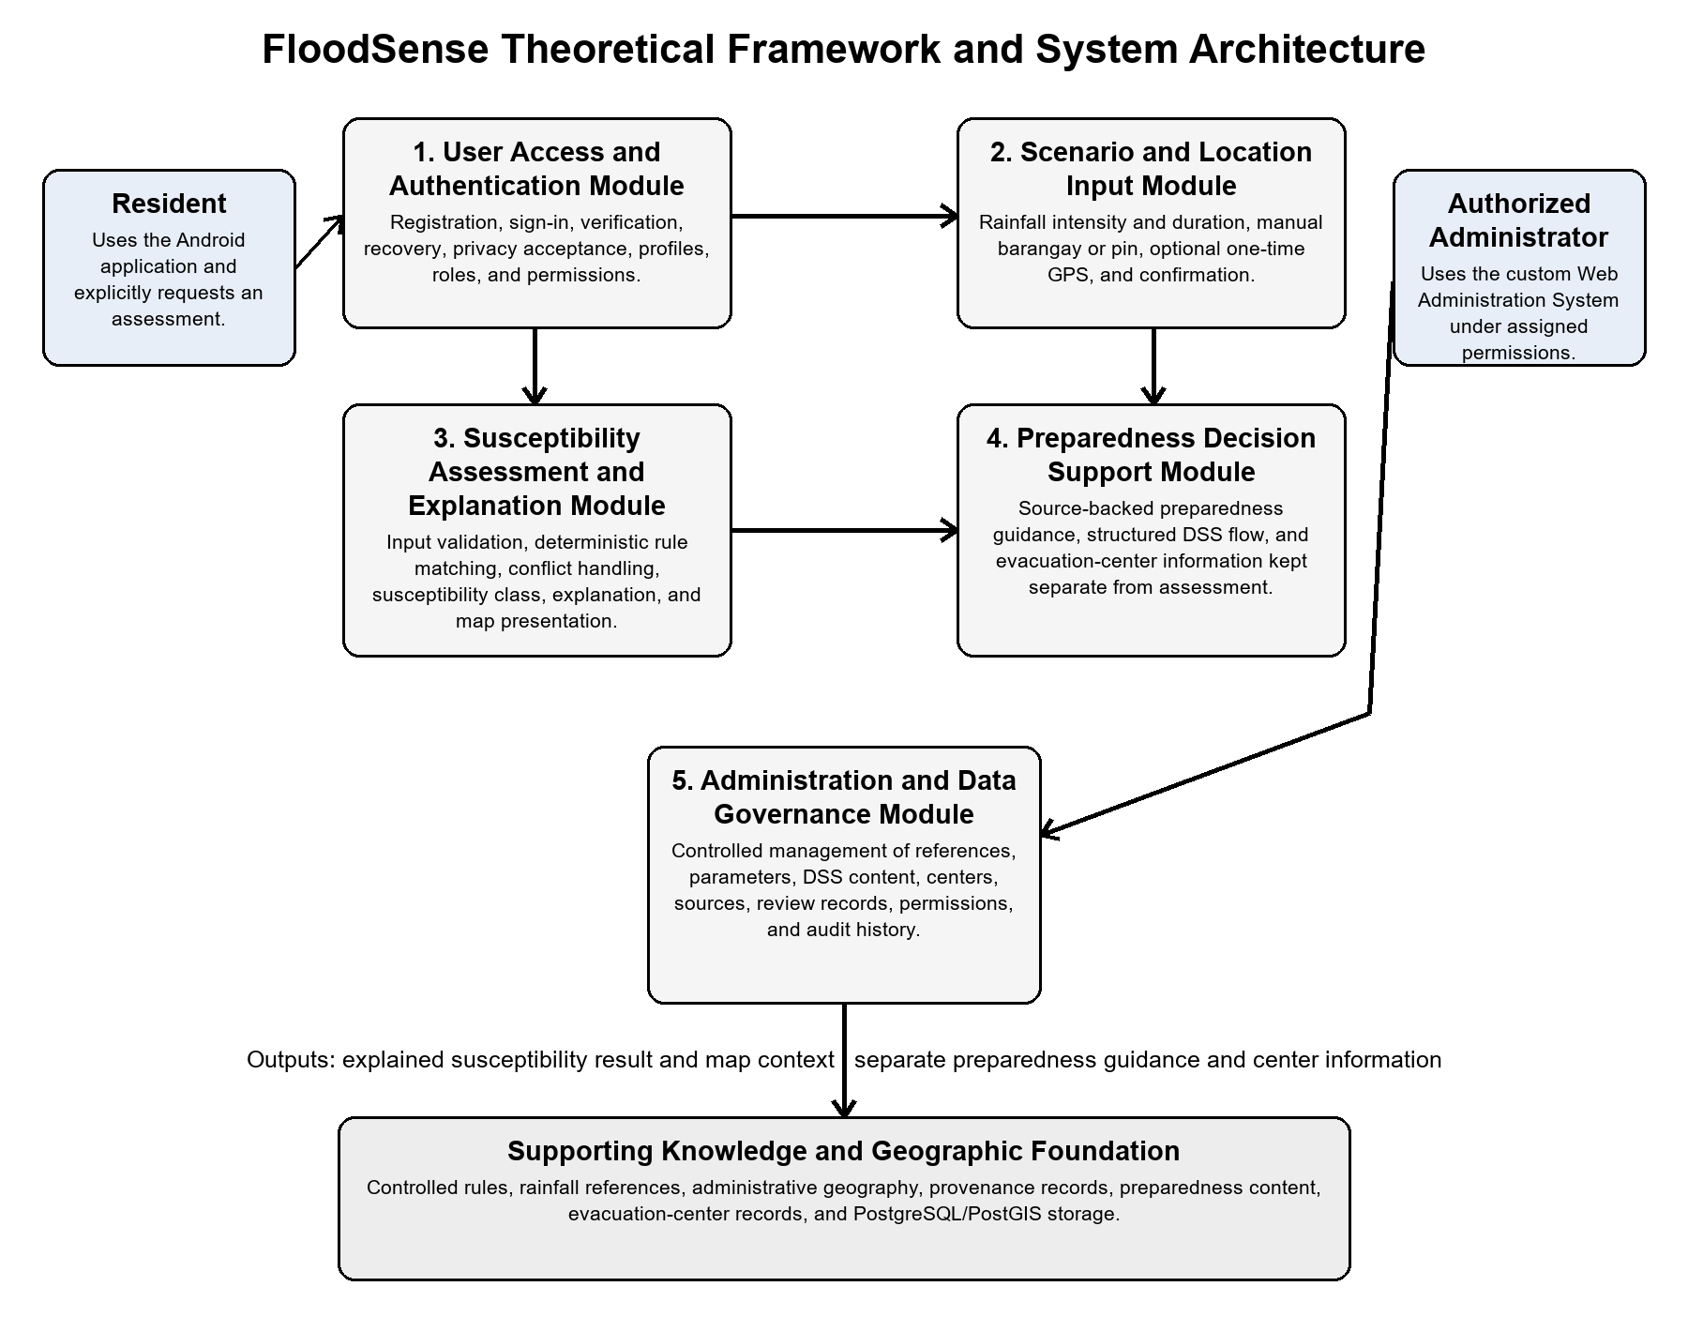
Figure 1. FloodSense Theoretical Framework and System Architecture
System Architecture
[Insert System Architecture]
Significance of the Study
FloodSense contributes an evidence-based approach to scenario-oriented flood preparedness by combining an explained susceptibility assessment with separate guidance and visible information boundaries.
For the Bacoor Disaster Risk Reduction and Management Office. The study may provide a complementary channel for presenting validated preparedness and evacuation-center information while retaining source, review, and audit records. It does not replace official warning, response, or emergency-command functions.
For the City Planning and Development Coordinator Office. The study demonstrates how appropriately authorized administrative and geographic information may support location-specific public communication while maintaining provenance and validation requirements.
For Bacoor City residents. The resident application provides a user-initiated process for confirming a hypothetical rainfall scenario and location, requesting an explained susceptibility result, viewing geographic context, and obtaining structured preparedness information.
For future researchers. The study documents the separation of deterministic assessment from preparedness guidance, the importance of authentication and role control, and the distinction among technical processing, scientific validation, and institutional authorization. Its procedures and findings require renewed validation before use in another locality.
Time and Place of the Study
The study is centered in Bacoor City, Cavite, with development and manuscript preparation at Cavite State University-Bacoor City Campus. A CPDCO interview was conducted in May 2026; BDRRMO interviews and a prototype discussion supplied further institutional context during the study period.
The initial resident survey collected responses in October 2026. The principal development and manuscript period extends from September 2026 through the planned completion in May 2027.
Scope and Limitation of the Study
FloodSense covers a connected Android application for Bacoor City residents and a browser-based administration system for authorized personnel. Residents can authenticate, select or confirm a hypothetical rainfall intensity and duration, identify a location by barangay or map pin or use optional one-time foreground GPS, confirm the barangay, and explicitly request a pre-event assessment. A deterministic Rule-Based Expert System provides an explained susceptibility classification and map context; a separate Decision Support System provides source-backed preparedness guidance and evacuation-center reference information. The administration system governs authorized access and review of rainfall and map references, assessment parameters, preparedness content, evacuation-center records, sources, and audit records. Ordinary administrators cannot rewrite raw rules, priorities, conflict-resolution logic, or algorithm code.
However, FloodSense is limited to scenario-based assessment and preparedness support within its documented Bacoor administrative coverage. It does not continuously monitor rainfall or water level, provide official forecasts or warnings, issue autonomous alerts or evacuation orders, track GPS in the background, determine safe routes, report live center occupancy, or use machine-learning prediction. Its 47-barangay layer is an administrative reference rather than a City-verified flood-susceptibility dataset; the authority and local validity of assessment inputs and guidance remain dependent on source documentation, expert review, and institutional validation. Evacuation-center distance is a straight-line reference and does not establish road safety, accessibility, opening status, or capacity. Connected functions require a compatible device and network access, while personal and temporary location information remain subject to consent and purpose limitation. The purposive survey of 40 respondents cannot represent every Bacoor resident.
Definition of Terms
The following terms are defined operationally as they are used in this study to ensure clarity and consistency throughout the research:
Android Application. The resident-facing FloodSense software developed with Flutter. It includes authentication, legal acceptance, onboarding, scenario and location confirmation, assessment requests, map/results presentation, structured preparedness guidance, nearest-center information, preferences, and account controls. It does not provide live alerts, assessment history, fully offline operation, or official warnings.
Check My Area. The location-selection flow that allows manual area selection, placement or adjustment of a map pin, and an optional one-time foreground location request. A detected barangay is proposed for user confirmation or correction before assessment; the function does not continuously track the device.
Color-Coded Susceptibility Levels. The visual scheme used on the dynamic map in which green indicates Low, yellow indicates Moderate, orange indicates High, and red indicates Very High flood susceptibility for the active scenario.
CPDCO (City Planning and Development Coordinator Office). The Bacoor City office that maintains planning and geographic information, including elevation, land-use, flood-hazard, and barangay-boundary materials relevant to the study.
Decision Support System (DSS). The component separate from the Rule-Based Expert System that presents published preparedness guidance and structured questions using the assessment context. It does not change the susceptibility result, issue an official warning or evacuation order, or make the user's final decision.
Dynamic Map. The provider-aware interactive map that supports panning, zooming, scenario-dependent demonstration coloring, manual selection, map-pin placement, foreground location, reference boundaries, and center markers when data are available. Its display does not convert provisional data into official hazard information.
Expert Knowledge and Validation. Flood-related facts, parameters, rules, preparedness guidance, and supporting information that require review by qualified experts and adequate provenance before being treated as locally valid. Repository presence or technical validation alone does not establish institutional approval.
Expert System. A knowledge-based computer system that applies stored facts and conditional rules through an inference process. In FloodSense, it produces an explainable susceptibility class for a supported geographic area and rainfall scenario.
Flood Susceptibility. The relative potential of a supported geographic area to experience rainfall-related flooding under a user-confirmed scenario. FloodSense expresses the assessment as Low, Moderate, High, or Very High and identifies it as a research-system output rather than an official Bacoor City classification or real-time prediction.
Geographic Information System (GIS). A system for organizing, analyzing, and presenting information associated with geographic locations. FloodSense uses GIS functions for polygons, points, containment queries, interactive visualization, and evacuation-center locations.
GeoDjango. The geographic extension of Django used by FloodSense to represent spatial data and perform geographic operations between backend services and the PostGIS database.
Inference Process. The procedure that matches facts from the selected rainfall scenario and geographic area against validated rules in the knowledge base to derive a susceptibility conclusion and supporting explanation.
Knowledge Base. The structured collection of documented facts, conditional rules, geographic attributes, rainfall parameters, susceptibility categories, and provenance records used by the Expert System. These materials require appropriate expert and institutional validation before they can be treated as authoritative local evidence.
Rainfall Scenario Input. A user-selected hypothetical rainfall intensity and duration used to request a pre-event assessment. The choices are scenario labels, not automatically updated observations, official forecasts, or official warning thresholds.
PostGIS. The spatial extension of PostgreSQL used to store and query FloodSense geographic polygons, points, boundaries, selected locations, and evacuation-center coordinates.
Preparedness Provenance. Information identifying the source, validation status, responsible actor, relevant date, and version of a preparedness item or related record. Provenance permits users and administrators to distinguish approved, provisional, and unsupported information.
Rainfall Parameters. The supported combination of rainfall intensity and duration selected by the user and applied as scenario facts during Expert System assessment.
Rule-Based Expert System. An Expert System in which domain knowledge is represented as conditional rules. FloodSense evaluates applicable rules against known scenario and geographic facts to produce a susceptibility assessment.
Web Administration System. The custom browser-based interface used by authorized administrators for dashboards and permission-controlled workflows involving map and rainfall references, parameters, DSS content and structured flows, evacuation centers, data sources, review records, and audit history. It does not expose raw rule editing. Technical Django Admin is separate and is reserved for developer or research maintenance.

REVIEW OF RELATED LITERATURE
This chapter presents a review of related literature, articles, and studies that provide guidance in identifying and formulating the requirements needed to start the project. Moreover, this chapter was designed to examine relevant concepts, methods, challenges, and practices associated with flood-susceptibility assessment, geographic information systems, Rule-Based Expert Systems, and Decision Support Systems.
Related Foreign Literature
Flood Susceptibility and Scenario-Based Assessment
Flood susceptibility expresses the relative tendency of a location to experience flooding when relevant conditions are present. It differs from flood hazard, which concerns the probability and physical characteristics of an event; exposure, which concerns people or assets in affected places; vulnerability, which concerns the capacity to be harmed; and risk, which combines hazard and potential consequences. Membele, Naidu, and Mutanga (2022) found that flood-vulnerability mapping in developing countries varies substantially in terminology, indicators, spatial scale, data availability, and validation practice. Their review shows why a public system must name the type of assessment it performs and avoid presenting a general vulnerability or hazard map as a locally validated susceptibility conclusion.
Scenario-based assessment supports planning by holding selected conditions explicit instead of implying that the system is observing an event as it occurs. A hypothetical rainfall intensity and duration can be treated as assessment inputs only when their meanings, permitted combinations, and geographic applicability are documented. This supports the FloodSense interaction in which the resident selects or confirms a scenario before requesting assessment. It does not establish that the scenario is current, predicted, or officially issued, and it does not justify importing weights or thresholds derived for another place.
Deterministic Rule-Based Expert Systems and Knowledge Bases
A Rule-Based Expert System represents domain knowledge through facts, conditions, and production rules and applies an inference procedure to derive a conclusion. Buchanan and Shortliffe (1984) provide the foundational distinction between the knowledge base and the inference mechanism. More recently, Papadopoulos et al. (2022) reviewed technologies and standards used in rule-based decision-support systems and described how encoded knowledge and rules engines evaluate case-specific facts. Although their review concerns clinical systems, the architectural distinction is relevant to FloodSense: flood knowledge, scenario facts, geographic facts, and explanations belong to controlled knowledge structures, while the inference procedure determines which eligible rule applies.
Deterministic processing means that the same approved facts and the same published rule version should produce the same result. It does not imply that the rules are scientifically valid merely because the software executes them consistently. Knowledge acquisition, conflict handling, parameter definitions, version control, and expert or institutional validation remain necessary. Accordingly, ordinary FloodSense administrators may manage authorized records and permitted values but do not rewrite raw rule conditions, priorities, conflict-resolution logic, or algorithm code.
Explainable Inference
Explainability is necessary when a system produces a classification that may influence preparedness decisions. Kostopoulos, Davrazos, and Kotsiantis (2024) reviewed explainable decision-support approaches and emphasized transparency, interpretability, and human-understandable justification. Their review primarily addresses artificial-intelligence-based systems, but its communication principles apply to deterministic inference: a user should be able to understand the relevant inputs, the basis of the result, and the limitations of the evidence without being required to inspect source code or raw rule definitions.
For FloodSense, an explanation should identify the confirmed rainfall scenario, resolved geographic context, susceptibility class, applicable basis, source or version information, and any limitation state. This supports accountability while preserving the distinction between explanation and rule administration. It also prevents a color or label from appearing authoritative without disclosing what it represents. Explainability does not remove the need for validated data, and a clear explanation cannot turn provisional information into an official local assessment.
Decision Support and Preparedness Guidance
A Decision Support System organizes information, alternatives, or recommended actions to assist human judgment. In flood preparedness, support may include understandable mitigation choices, household preparation, communication planning, protection of documents and valuables, assistance for vulnerable household members, attention to official advisories, and evacuation readiness. Mostafiz et al. (2022) observed that many web-based flood tools provide technical information but do not consistently provide locally actionable information for individuals and communities. Their review supports combining understandable risk communication with practical guidance while clearly stating the tool's authority and limitations.
FloodSense separates the susceptibility assessment from preparedness guidance. The deterministic Expert System produces the assessment, while the DSS presents source-backed pre-event guidance without changing the susceptibility class. Information about evacuation facilities may support readiness when its source, verification date, location, and operational limitations are known, but distance alone does not prove route safety, current opening, accessibility, or available capacity. The DSS therefore assists preparation and does not issue an official warning, evacuation order, or guarantee of safety.
GIS, Interactive Maps, and Spatial Databases
Geographic Information Systems organize, analyze, and present information associated with locations. Their value in flood research depends on the suitability of the layers, coordinate reference systems, spatial resolution, classification methods, and validation procedures. An administrative boundary can resolve the name of a barangay or provide map context, but it contains no flood-susceptibility fact unless appropriate hazard or susceptibility evidence has been associated with it. This distinction is important when users may interpret any colored polygon as an official hazard layer.
Spatial databases support the controlled storage and querying of geographic records. The PostGIS Development Group (2026) explains that PostGIS extends PostgreSQL with geometry and geography types, spatial indexes, spatial relationships, coordinate transformation, validity operations, and spatial processing. These capabilities are relevant to point-in-polygon queries, administrative-area lookup, map-feature storage, and provenance-linked geographic records. They provide technical infrastructure, not scientific validation: a valid geometry and a successful spatial query do not establish that a flood conclusion is institutionally approved.
Flood-Risk Communication
Flood-risk information must be understandable, actionable, and explicit about uncertainty. Mostafiz et al. (2022) identified gaps in web-based flood communication, particularly where tools provide information without sufficiently connecting it to decisions that residents can make. Clear terms, legends, labels, explanation text, and source notices help prevent non-specialists from treating model outputs as certain predictions. Communication should also distinguish long-term or scenario-based information from time-sensitive official warnings.
These principles support a guided FloodSense flow rather than an unexplained technical map. Susceptibility colors must be paired with text, the selected scenario, and limitations. Preparedness information must direct users toward official channels during actual events. The interface must not imply that a neutral boundary layer, a demonstration color, or a provisional record represents a current flood condition.
Data Provenance and Geographic Validation
Provenance records where information originated, how it was transformed, which version was used, and what review or approval applies. Tullis and Kar (2021) connected provenance to ethical replicability and reproducibility in GIScience, including critical applications in which geographic data affect public decisions. Fakhruddin et al. (2022) similarly emphasized risk-informed data practices and the importance of understanding how disaster and climate data are produced, shared, interpreted, and governed.
For FloodSense, provenance should accompany susceptibility parameters, geographic layers, preparedness items, and resource information. Technical geometry validation may confirm coordinate-system consistency, valid shapes, or feature counts, but institutional validation concerns authority, currency, meaning, and permitted public use. The two forms of validation are related but not interchangeable. This distinction prevents a technically processed dataset from being represented as official Bacoor City flood information without documented approval.
Foreground Location and Privacy
Mobile location can reveal a person's position and may contribute to identification or tracking. Android Developers (2026) distinguishes foreground access, one-time access, and background access and recommends requesting only the permission needed for the active function. This supports a FloodSense flow in which location is obtained only after a user initiates location selection or assessment, while manual selection remains available when the resident declines permission or prefers another area.
Foreground acquisition does not imply continuous monitoring. FloodSense does not require background GPS tracking, automatic polling, or autonomous location-based alerts. Location handling should remain purpose-limited to the active assessment, use only the precision necessary for the supported geographic operation, and avoid retaining unnecessary movement information. The presentation must also allow the user to confirm or correct the detected barangay because device accuracy and boundary proximity can affect geographic resolution.
Software Testing and Quality Evaluation
Software testing establishes whether specified behavior is implemented under defined conditions, while quality evaluation examines broader product characteristics. ISO/IEC 25010:2023 defines a product-quality model with nine characteristics for specifying and evaluating information and communication technology products (International Organization for Standardization [ISO], 2023). The model can guide the selection of criteria for FloodSense, but it does not provide a ready-made acceptance result or replace an approved evaluation instrument.
A defensible product-quality evaluation must identify the tested build, participants or evaluators, tasks, criteria, scale, procedure, valid responses, and interpretation method. Automated tests and interface demonstrations can support technical verification, but they are not user-acceptance findings. The completed initial survey is a needs assessment rather than a post-use system evaluation; therefore, Chapter 2 uses ISO/IEC 25010 as literature supporting the planned product-quality assessment and does not report FloodSense evaluation scores.
Existing Foreign Flood-Information Platforms
Foreign platforms demonstrate several forms of flood information without constituting transferable evidence for Bacoor City. FloodAdapt uses SFINCS-based scenario simulation and Delft-FIAT impact analysis to compare flood events and adaptation options (Deltares, 2025). The Global Flood Awareness System applies large-scale hydrological modeling to operational river-flood forecasting (Copernicus Emergency Management Service, 2026), while the Iowa Flood Information System combines Iowa-specific observations, radar rainfall, forecasting, and mapped information (Iowa Flood Center, 2024). These services illustrate scenario analysis, forecasting, and public communication, but their models, data, scales, and authority differ from FloodSense.
The Resilience Analysis and Planning Tool combines United States hazard, infrastructure, demographic, and community-resilience layers for emergency-management planning (Federal Emergency Management Agency, 2025). England's National Assessment of Flood and Coastal Erosion Risk similarly communicates modeled long-term risk from several flood sources at national scale (Environment Agency, 2024). These official resources show the value of visible limitations, data context, and geographic lookup; however, they are platforms and institutional assessments rather than FloodSense research studies, and their datasets and classifications cannot validate a Bacoor City susceptibility result.
Related Local Literature
Philippine Flood Conditions and Institutional Preparedness
Official Philippine statistics continue to record substantial effects from extreme events and disasters. The Philippine Statistics Authority (PSA, 2026) summarizes national information on disaster occurrence, affected populations, deaths, and economic losses. These national figures establish the continuing relevance of disaster preparedness but do not identify the susceptibility of a particular Bacoor barangay or validate the inputs of a local application.
The National Disaster Risk Reduction and Management Council's National Disaster Response Plan identifies institutional responsibilities and coordinated actions for hydro-meteorological hazards (NDRRMC, 2024). The plan reinforces that warnings, response decisions, and emergency coordination belong to authorized government mechanisms. FloodSense may support pre-event understanding and preparedness, but residents must continue to follow PAGASA, local disaster offices, barangay authorities, and emergency responders during an actual event.
Official Hazard Information and Warning Authority
PAGASA operates rainfall and flood-information processes that use observations, forecasts, water-level information, and coordinated warning protocols. Its 2023 Annual Climate Bulletin explains the role of rainfall warning systems and the use of official warning levels for public action (PAGASA, 2024). FloodSense rainfall selections are hypothetical assessment inputs; they are not automatic updates from PAGASA, an interpretation of current rainfall, or an official warning product.
GeoRisk Philippines presents HazardHunterPH as a national platform for site-specific indicative multi-hazard assessment using official information from participating government agencies (GeoRisk Philippines, 2023). Its source notices and limitations demonstrate responsible hazard communication. The same principle applies to FloodSense: sources, dates, limitations, and validation status should remain visible, and an indicative or provisional record should not be represented as an absolute prediction.
Cavite, Bacoor City, and the Imus River Basin
The Japan International Cooperation Agency reported the inauguration of flood-mitigation facilities associated with the Imus River Basin and low-lying areas of Imus and Bacoor (JICA, 2021). This institutional record confirms the relevance of watershed and infrastructure conditions to the local context. It does not provide barangay susceptibility classifications, rainfall-rule thresholds, or validation for FloodSense, and it should not be treated as a substitute for hydrologic or hazard data.
Administrative geography in Bacoor has also changed. The PSA documented the 2023 merger and renaming of barangays and currently lists 47 barangays in the City of Bacoor (PSA, 2023, 2025). These records support the current identities used in a reference layer. They do not establish the accuracy of every derived polygon, City verification of a third-party boundary, or flood conditions within any barangay. Administrative reference and flood-susceptibility evidence must therefore remain separate.
Administrative Data Governance and Responsible Use
Government publications, local records, and research datasets differ in authority and permitted use. An official list of administrative units may verify names and codes, while an authorized hazard agency may provide hazard information, and a local office may validate operational records. Combining these sources requires documentation of ownership, date, scale, processing, approval, and restrictions. Provenance is particularly important when a dataset has been transformed, because technical processing can change geometry or attributes without changing the institution responsible for the original information.
FloodSense consequently distinguishes approved, provisional, technically validated, and unsupported information. The 47-barangay layer may serve as a current administrative reference after documented derivation and geometry checks, but it is not a flood-susceptibility layer and is not automatically City-issued or City-verified. No operational susceptibility dataset should be described as established until the necessary source, method, expert review, institutional authority, and database integration are documented.
Philippine Data Privacy and Software-Quality Context
Republic Act No. 10173, the Data Privacy Act of 2012, requires personal-information processing to observe transparency, legitimate purpose, and proportionality. For a resident-facing location function, these principles support clear notice, user initiation, limited collection, secure handling, and avoidance of continuous background tracking. They also support role-controlled administrative access. The Act is legally authoritative despite falling outside the preferred publication period for recent literature.
Philippine software studies have also used ISO/IEC 25010 as an evaluation framework, but the criteria and edition must be identified accurately. An evaluation of another application cannot be transferred to FloodSense, and the presence of a questionnaire does not establish completed results. FloodSense quality conclusions will require its own approved instrument, respondents or evaluators, documented procedure, and completed analysis.
Philippine Flood-Susceptibility and Risk Mapping
Puno et al. (2022) used GIS frequency-ratio analysis, 160 flashflood inventory points, and nine conditioning factors to map susceptibility in Barangay Bukang Liwayway, Bukidnon. Gacu et al. (2022) combined hazard, vulnerability, and exposure parameters through a GIS-based analytical hierarchy process in Odiongan, Romblon, using judgments from ten experts and end-users and checks against ground assessment and historical events. These studies demonstrate documented local spatial methods and validation practices, but they are mapping investigations rather than resident-facing flood-information systems.
Their factors, weights, classifications, geographic scales, and reported results are specific to their study areas. They support the need for local data and validation but do not provide Bacoor City rules or an operational susceptibility dataset. Accordingly, they are retained as Philippine literature relevant to spatial assessment and are not presented in the system-study comparison tables.
Existing Philippine Hazard-Information and Planning Platforms
UP NOAH remains an important Philippine reference for accessible geographic hazard information. Lagmay et al. (2017) documented the dissemination of near-real-time hazard information and flood maps through Web-GIS using open-source code and application programming interfaces. The dated publication supports discussion of public map-based risk communication, while the general platform should not be treated as a research study with an invented SDLC. UP NOAH differs from FloodSense because its documented hazard-information resources were institutionally developed, whereas FloodSense is a scenario-based research prototype and is not an official forecasting or warning platform.
HazardHunterPH is a GeoRisk Philippines application that produces site-specific indicative multi-hazard assessments from official agency information (GeoRisk Philippines, 2023). Its rapid geographic lookup and source-based reporting are relevant to FloodSense's emphasis on accessible information, provenance, and visible limitations. It remains an official platform rather than a substitute for locally validated FloodSense rules or data, and its reports do not confer forecasting or warning authority on FloodSense.
GeoMapperPH supports governed collection of hazard, exposure, vulnerability, and coping-capacity information by trained government and agency users, while PlanSmartPH Ready to Rebuild organizes information for local-government rehabilitation and recovery planning (DOST-PHIVOLCS, 2022a, 2022b). These platforms illustrate structured data governance and institutional workflows. They are discussed as existing Philippine systems, not retained as Related Studies, because the inspected official pages do not provide a complete research methodology and results section suitable for the comparative study tables.
Related Foreign Studies
Design and Implementation of Real-Time Flood Early Warning System (FEWS) Based on IoT Blynk Application: An Arduino- and GSM-Based Mobile Flood-Warning System
Wisudawan (2021) investigated a mobile-connected Flood Early Warning System for a reservoir at Universitas Islam Indonesia in Sleman, Yogyakarta. The work addressed the need to observe local environmental conditions and communicate warning levels to a mobile user. Its purpose was continuous site monitoring, not the assessment of a hypothetical rainfall scenario.
The researcher assembled an Arduino Nano with rainfall, water-level, temperature, and humidity sensors, GSM communication, and the Blynk Android application. The prototype was checked in sensor tests and then observed at the reservoir for 30 days. Readings were categorized into Normal, Advisory, Watch, and Warning states; the source did not name a formal software-development life-cycle model.
During the observation period, the reported mean temperature was 28.6 degrees Celsius, mean humidity was 63.7%, and mean water level was 54.5 centimeters. The paper documented transmission and display of readings and warning states. No flood occurred during field observation, so the study did not demonstrate warning performance during an actual flood event.
The prototype illustrates how environmental measurements can be presented understandably on a mobile interface. Its one-reservoir setting, short observation period, and sensor thresholds limit transferability to other places. FloodSense instead uses a resident-confirmed hypothetical scenario and deterministic susceptibility rules; the Indonesian sensor readings cannot validate Bacoor City conditions.
A User Experience Evaluation of a Mobile Application for Disseminating Site-Specific Impact-Based Flood Warnings: The A4alerts App: A Mobile Application for Site-Specific Impact-Based Flood Warnings
Meléndez-Landaverde and Sempere-Torres (2023) examined A4alerts, a mobile application for disseminating site-specific, impact-based flood warnings in Catalonia, Spain. Their research asked whether users considered the application and its warning-related functions useful in an emergency context. The app drew on an operational warning environment rather than a stand-alone hypothetical susceptibility exercise.
Seventy-six civil-protection, emergency-response, and local stakeholders completed an online interactive scenario experiment between January and March 2022. The researchers assessed perceived usefulness, functional appropriateness, and willingness to adopt the app and compared feature rankings using Friedman's test and Bonferroni-adjusted Wilcoxon comparisons. The participant experience was a demonstration, not observation of behavior during a real flood.
Ninety-seven percent of participants considered A4alerts useful during flood emergencies, while 93% said they would use or recommend it. Site-specific impact warnings, official regional warnings, and a self-protection checklist were among the most valued functions. These are reported perceptions of the recruited participants, not evidence of an observed reduction in flood losses.
The study supports careful presentation of place-specific information and actionable guidance. Its stakeholder sample, Catalan warning infrastructure, and scenario experiment constrain generalization to Bacoor City residents. FloodSense can draw on its communication lessons but does not disseminate official operational warnings or inherit the evaluated app's performance.
Real-Time Flood Forecasting and Warning: A Comprehensive Approach toward HCI-Centric Mobile App Development: A Human-Centered Mobile Flood-Forecasting and Warning Prototype
Alsabhan and Dudin (2023) developed and evaluated a human-computer-interaction framework and prototype for mobile real-time flood forecasting and warning. The study focused on the tasks and information needs of front-end users, weather-station users, and administrators. Its research problem concerned a multi-role forecasting environment rather than pre-event assessment initiated by a resident.
Activity theory and scenario-based design guided nominal-group sessions with five prospective users and five experts. Participants generated 63 situations, from which 12 priority scenarios informed requirements and prototype tasks. The researchers evaluated task performance and satisfaction across usefulness, ease of use, learnability, satisfaction, and overall experience; no Agile, Waterfall, or other SDLC was stated as the study's development model.
The process produced 87 initial requirements and six additional requirements after testing, for a total of 93. Mean satisfaction-category scores ranged from 3.93 to 4.08, although some analytical tasks were harder for participants. The reported prototype and evaluation therefore give evidence about requirements and interaction quality, not about forecast accuracy in Bacoor City.
This study shows why role-specific access and understandable interactions matter in a flood-information application. Its small participant groups and forecasting architecture limit wider inference. FloodSense shares the need for comprehensible outputs and permissions, but its deterministic, resident-requested susceptibility assessment is separate from real-time forecasting and warning.
Developing a Climate-Smart Web GIS App for Multi-Hazard Early Warning against Climate-Based Disaster Risks: A Tanzanian Web GIS for Flood and Drought Early Warning
Msusa et al. (2025) investigated a climate-smart Web GIS application for multi-hazard early warning in Tanzania. Flood analysis focused on Dar es Salaam, while drought analysis focused on Dodoma. The authors sought to bring modeled hazard information and local knowledge into an accessible geographic application for planning and warning purposes.
For flooding, the researchers used Height Above Nearest Drainage analysis, GloFAS forecast information, and community-mapped flood points for spatial comparison. For drought, they used geospatial climate inputs and a ConvLSTM model. The paper expressly identified Rapid Application Development as its Web GIS development process; these hydrological, machine-learning, and development procedures served different methodological roles.
The mapped flood points showed qualitative spatial agreement with the flood-model output. The reported median ROC-AUC of 0.87 and median F1 score of 0.81 refer to the drought model, not to the flood analysis. The application brought these multi-hazard outputs together in a Web GIS interface.
The study demonstrates the value of combining spatial analysis, local validation, and accessible map presentation. Its forecast data, modeling choices, and Tanzanian geographic conditions cannot be transferred directly to Bacoor City. FloodSense uses deterministic scenario-based assessment and cannot claim the study's early-warning or machine-learning results as its own.
Related Local Studies
Web-Based Solution for Flood Warning Decision Support in the Province of Leyte, Philippines: An IoT Rainfall- and Water-Level Decision-Support Prototype
Bentoso et al. (2021) presented a web-based flood-warning decision-support prototype for the Province of Leyte, Philippines. The project addressed the need to display rainfall and water-level conditions in a form usable by authorities making warning and flood-control decisions. Its subject was measured environmental conditions, not a resident-selected hypothetical scenario.
The available institutional publication describes rainfall and water-level sensing, transmission of readings to a web interface, graphical reporting, and alert messages for responsible personnel. This is a documented technical procedure, but the accessible institutional record does not establish a named research design or software-development model. Details of sample size, field duration, and threshold calibration were not available for independent confirmation from that record.
The authors reported a functional prototype that graphically displayed the flooding situation and sent alert-level messages to support monitoring and planning. The accessible record does not establish province-wide deployment or measured preparedness outcomes. The reported output is therefore treated as a prototype contribution rather than proof of operational effectiveness throughout Leyte.
The work is relevant to digital presentation of flood information for decision support. Its sensor-and-alert design differs from FloodSense's resident-requested susceptibility assessment and separate preparedness guidance. Leyte-specific readings and thresholds cannot establish the validity of Bacoor City classifications, and the limited accessible methodological detail constrains comparison.
Isabela City Flood Monitoring System Using Arduino and GSM Module: An Arduino and GSM Flood-Monitoring and SMS-Warning System
Carpio, Asnaul, Said, and Amerin (2022) developed an Arduino and GSM flood-monitoring system for Riverside Barangay in Isabela City, Basilan. The system was intended to observe water conditions and communicate warning signals to local disaster personnel. It addressed a local monitoring problem rather than the interpretation of a hypothetical resident-chosen rainfall scenario.
The authors explicitly used an Agile Development Model for incremental system construction and a quantitative survey design for evaluation. Twenty City Disaster Risk Reduction and Management Office personnel participated in a demonstration and initial device test. They assessed functionality, design, security, efficiency, and reliability, making the survey an evaluation of the prototype under the reported conditions.
The paper reported an overall mean of 3.70, interpreted by its authors as Acceptable, and described warning-signal operation during testing. It also reported that battery operation was limited to approximately ten hours. These results describe the tested device and evaluator group; they do not show sustained warning performance across Isabela City.
The Philippine setting provides a useful comparison for local disaster-information systems and for distinguishing development method from evaluation design. However, its hardware, threshold conditions, respondent group, and measured outcomes cannot be transferred to Bacoor City. FloodSense does not continuously monitor water level or send autonomous SMS warnings.
IOT-Based Flood Alert System for Narvacan, Sto. Tomas, La Union: A Water-Level Monitoring, Web, and SMS Alert Prototype
Dela Cruz et al. (2024) developed an IoT flood-alert prototype for Barangay Narvacan in Sto. Tomas, La Union. The project responded to a community need for water-level information and alert delivery through a connected system. Its purpose was to develop the local prototype and examine its acceptability among intended community participants.
The authors identified descriptive and developmental research designs and used Agile for application development. Interviews and observations informed the prototype, while purposive sampling selected nine barangay council officials and 21 residents from seven sectors, for 30 evaluators in all. The User Technology Acceptability Questionnaire measured perceived usefulness, information quality, and interface quality after testing.
On the study's seven-point scale, the reported criterion means were 6.87 for usefulness, 6.83 for information quality, and 6.82 for interface quality. The source also prints a grand mean of 6.87, which does not match the simple average of those three displayed criterion means; this review therefore reports the individual criterion results without adopting the inconsistent aggregate. The ratings document acceptability among the selected evaluators, not field effectiveness during a flood.
The work offers a local example of combining community consultation, iterative development, and user evaluation. Its single-barangay sample, continuous water-level sensing, and SMS-alert function differ from FloodSense's pre-event scenario assessment. Neither its acceptability ratings nor its sensor thresholds can validate a Bacoor City susceptibility result.
BantayBaha: Flood Monitoring System with SMS Notification: An IoT Water-Level Monitoring, Web-Logging, and SMS Notification System
Delos Reyes, Cabreros, Paulino, and Garcia (2020) developed BantayBaha for Barangay Virgen Delas Flores in Baliwag, Bulacan. The project addressed the barangay's manual water-level measurement and megaphone-based warning practices. It proposed a connected monitoring, website-logging, and SMS-notification prototype for that setting.
The authors interviewed local officials and rescue personnel to understand practices and define water-level states. They built an IoT prototype, carried out verification, validation, and repeated tests, and then asked 70 Baliuag University students to evaluate it. The source documents these procedures but does not expressly name a formal SDLC model.
The student evaluators rated functionality at 4.70, user interface at 4.50, and reliability at 4.57 on the paper's five-point scale; the authors interpreted each as Very Satisfactory. The prototype also demonstrated water-level recording and SMS notification under its test conditions. These ratings do not constitute a field trial of warning impact among all barangay residents.
BantayBaha illustrates a Philippine effort to improve local communication of monitored water levels. Its single-barangay location, student evaluator group, and hardware requirements limit generalization. FloodSense does not adopt continuous sensing or automated SMS alerts, and the Bulacan results do not establish the validity of Bacoor City scenario assessments.
Synthesis of the Reviewed Literature
The reviewed literature and systems demonstrate several established approaches to flood information: sensor-based monitoring, forecast dissemination, Web GIS, mobile warnings, explainable interfaces, preparedness checklists, and Philippine SMS alert prototypes. The foreign systems show that usefulness depends on clear location context, role-appropriate interfaces, understandable warnings, and evaluation with users or geographic data. The Philippine systems show that local implementations commonly combine sensors, web or mobile presentation, and alert messages, although their thresholds, hardware, samples, and findings remain tied to their respective communities.
These systems agree that flood information must be understandable and connected to action, but they differ in purpose, authority, data, method, geographic scale, and disaster-management phase. Wisudawan (2021), Bentoso et al. (2021), Carpio et al. (2022), Dela Cruz et al. (2024), and Delos Reyes et al. (2020) rely on sensed water or rainfall conditions. A4alerts disseminates warnings from an operational warning system, the HCI-centered prototype addresses real-time forecasting, and the Tanzanian Web GIS integrates forecast and predictive models. FloodSense does not adopt these monitoring, forecasting, or automatic-warning functions.
The literature on susceptibility, GIS, deterministic rules, decision support, provenance, privacy, and software quality supports the verified FloodSense design. FloodSense combines a resident-confirmed hypothetical rainfall scenario and location with deterministic rule matching, an explained susceptibility output, and preparedness guidance that remains separate from assessment. Authentication, roles, source records, review status, and administrative controls support responsible use. These design choices do not eliminate the need for locally appropriate knowledge, geographic validation, expert review, and institutional authorization.
The methods and results of the reviewed systems cannot be transferred directly to Bacoor City. Sensor thresholds, hydrological models, participant ratings, map classes, forecast inputs, and reported accuracy were produced in different environments and for different users. Their contributions therefore guide concepts and methods rather than supplying Bacoor-specific susceptibility facts or proving that FloodSense is effective.
Research Gap
Existing studies already provide evaluated flood-monitoring devices, mobile warning applications, Web GIS platforms, and decision-support prototypes. What remains insufficiently addressed in the inspected evidence is a Bacoor-focused, public-facing flow in which a resident deliberately selects a hypothetical rainfall scenario and location, receives an explainable deterministic susceptibility result, and then accesses preparedness guidance as a separate form of support.
The gap also concerns provenance and local validity. None of the reviewed systems supplies an approved Bacoor City susceptibility knowledge base, locally validated rule thresholds, authorized geographic inputs, or evidence that external results can be generalized to the city's 47 barangays. FloodSense addresses the combination of scenario input, explainable rule-based assessment, location confirmation, separate preparedness support, authentication, and administrative governance as a research system. It remains distinct from official forecasting, warning, monitoring, and emergency-command systems.
Comparative Synthesis of Related Studies
The following tables compare the documented methodologies or technical procedures, objectives, and contributions of the foreign and Philippine system studies retained in this chapter. Each entry draws on an original publication or institutional record that describes a research or development procedure and an output, although the accessible methodological detail is not equal for every source.
Table 1. Comparison of related foreign studies
SYSTEM | AUTHOR(S)  YEAR | METHODOLOGY | OBJECTIVES | CONTRIBUTIONS
Design and Implementation of Real-Time Flood Early Warning System (FEWS) Based on IoT Blynk Application: An Arduino- and GSM-Based Mobile Flood-Warning System | Wisudawan (2021) | Arduino/Blynk/GSM system design and 30-day field observation of rain, temperature, humidity, and water level. | The study aimed to build and implement a real-time IoT flood early-warning system with mobile access. | It produced four warning states and reported 30-day mean sensor values; no flood occurred during observation.
A User Experience Evaluation of a Mobile Application for Disseminating Site-Specific Impact-Based Flood Warnings: The A4alerts App: A Mobile Application for Site-Specific Impact-Based Flood Warnings | Meléndez-Landaverde and Sempere-Torres (2023) | Online scenario-based user experiment with 76 participants; Likert evaluation, ranking, Friedman test, and Wilcoxon post hoc analysis. | The study aimed to evaluate the usefulness, functional appropriateness, and adoption of A4alerts. | It found 97% perceived usefulness and ranked site-specific warnings, official warnings, and self-protection guidance highest.
Real-Time Flood Forecasting and Warning: A Comprehensive Approach toward HCI-Centric Mobile App Development: A Human-Centered Mobile Flood-Forecasting and Warning Prototype | Alsabhan and Dudin (2023) | Activity theory and scenario-based design; nominal groups of five users and five experts; prototype task and satisfaction evaluation. | The study aimed to derive HCI requirements and evaluate a mobile real-time flood-forecasting and warning prototype. | It identified 93 design requirements, three user groups, and mean satisfaction scores from 3.93 to 4.08.
Developing a Climate-Smart Web GIS App for Multi-Hazard Early Warning against Climate-Based Disaster Risks: A Tanzanian Web GIS for Flood and Drought Early Warning | Msusa et al. (2025) | HAND/GloFAS flood analysis, participatory mapping, ConvLSTM drought modeling, and RAD Web GIS development. | The study aimed to develop a localized multi-hazard Web GIS early-warning application for Tanzania. | It reported strong spatial agreement for flood validation and drought-model median ROC-AUC 0.87 and F1 0.81.
Table 2. Comparison of related local studies
SYSTEM | AUTHOR(S)  YEAR | METHODOLOGY | OBJECTIVES | CONTRIBUTIONS
Web-Based Solution for Flood Warning Decision Support in the Province of Leyte, Philippines: An IoT Rainfall- and Water-Level Decision-Support Prototype | Bentoso et al. (2021) | Rainfall and water-level readings transmitted to a web system, converted to graphical reports, and used to send alert messages. | The study aimed to develop a web-based aid for monitoring flood conditions and supporting warning decisions in Leyte. | It reported graphical monitoring, alert messages to authorities, and decision-support information for flood-control planning.
Isabela City Flood Monitoring System Using Arduino and GSM Module: An Arduino and GSM Flood-Monitoring and SMS-Warning System | Carpio et al. (2022) | Agile Development Model; quantitative survey and initial device test with 20 CDRRMO personnel. | The study aimed to develop an Arduino/GSM system that monitors water level and sends SMS warnings. | It obtained an overall mean of 3.70, interpreted as Acceptable, and documented a ten-hour battery limit.
IOT-Based Flood Alert System for Narvacan, Sto. Tomas, La Union: A Water-Level Monitoring, Web, and SMS Alert Prototype | Dela Cruz et al. (2024) | Descriptive and developmental research; Agile; purposive UTAQ evaluation with 30 officials and residents. | The study aimed to develop an IoT flood-alert prototype and assess its acceptability in Barangay Narvacan. | It reported means of 6.87 for usefulness, 6.83 for information quality, and 6.82 for interface quality among 30 evaluators.
BantayBaha: Flood Monitoring System with SMS Notification: An IoT Water-Level Monitoring, Web-Logging, and SMS Notification System | Delos Reyes et al. (2020) | Barangay interviews, IoT prototype development, verification/validation, repeated tests, and evaluation with 70 students. | The study aimed to monitor water level, log readings on a website, and send SMS notifications in Virgen Delas Flores. | It reported means of 4.70 for functionality, 4.50 for interface, and 4.57 for reliability.
Table 3 shows that the reviewed systems primarily emphasize sensor-based monitoring, forecasting, warning dissemination, and web or mobile presentation. A4alerts adds site-specific communication and self-protection guidance, while the HCI-centered and Tanzanian systems demonstrate role-aware design and geographic analysis. FloodSense differs by combining a resident-confirmed hypothetical rainfall scenario, location confirmation, deterministic rule-based susceptibility assessment, an explained result, and separate preparedness guidance. The matrix is not a performance ranking; a blank cell means that the feature was not established by the inspected source.
Table 3. Comparison of developed study to the other existing systems.
Features | Existing Systems |  |  |  |  |  |  |  | FloodSense
 | S1 | S2 | S3 | S4 | S5 | S6 | S7 | S8
User-facing mobile or web interface | ✓ | ✓ | ✓ | ✓ | ✓ |  | ✓ | ✓ | ✓
Geographic or map-based presentation |  | ✓ | ✓ | ✓ |  |  |  |  | ✓
Sensor- or forecast-based monitoring | ✓ |  | ✓ | ✓ | ✓ | ✓ | ✓ | ✓
Automatic warning or alert dissemination | ✓ | ✓ | ✓ | ✓ | ✓ | ✓ | ✓ | ✓
Location-specific information |  | ✓ | ✓ | ✓ |  |  | ✓ |  | ✓
User-selected hypothetical rainfall scenario |  |  |  |  |  |  |  |  | ✓
Deterministic rule-based susceptibility assessment |  |  |  |  |  |  |  |  | ✓
Human-readable result context or explanation | ✓ | ✓ |  | ✓ | ✓ | ✓ | ✓ | ✓ | ✓
Preparedness or self-protection guidance |  | ✓ |  |  |  |  |  |  | ✓
Administrative management interface |  |  | ✓ |  |  |  | ✓ | ✓ | ✓
Legend:
✔ - included in the documented system; blank - not established by the inspected source.
S1 - Design and Implementation of Real-Time Flood Early Warning System (FEWS) Based on IoT Blynk Application
S2 - A User Experience Evaluation of a Mobile Application for Disseminating Site-Specific Impact-Based Flood Warnings: The A4alerts App
S3 - Real-Time Flood Forecasting and Warning: A Comprehensive Approach toward HCI-Centric Mobile App Development
S4 - Developing a Climate-Smart Web GIS App for Multi-Hazard Early Warning against Climate-Based Disaster Risks
S5 - Web-Based Solution for Flood Warning Decision Support in the Province of Leyte, Philippines
S6 - Isabela City Flood Monitoring System Using Arduino and GSM Module
S7 - IOT-Based Flood Alert System for Narvacan, Sto. Tomas, La Union
S8 - BantayBaha: Flood Monitoring System with SMS Notification
METHODOLOGY
This chapter describes the materials, participants, development process, and analysis used to investigate flood-information needs and construct FloodSense. It distinguishes the study’s research design from the software-development process and the management of development tasks.
Materials
The study used a bilingual resident needs-assessment questionnaire with a consent notice, Google Forms and face-to-face survey materials, exported responses, institutional interview guides, consented recordings and transcripts, request letters, relevant school documents, scholarly and official references, requirements records, interface designs, and software test records. A handwritten task board and Excel tracker supported task visibility; Messenger or Viber, Discord, and email supported coordination and institutional data requests.
Development materials included Windows computers, Android test devices, Git and GitHub for sharing and maintaining work, Flutter and Dart for the resident application, Python with Django and Django REST Framework for backend and administration services, PostgreSQL/PostGIS for relational and spatial storage, mapping components, and a browser-based administration interface. These tools supported implementation and technical checks; they did not establish the institutional or scientific validity of the geographic and susceptibility information.
Method
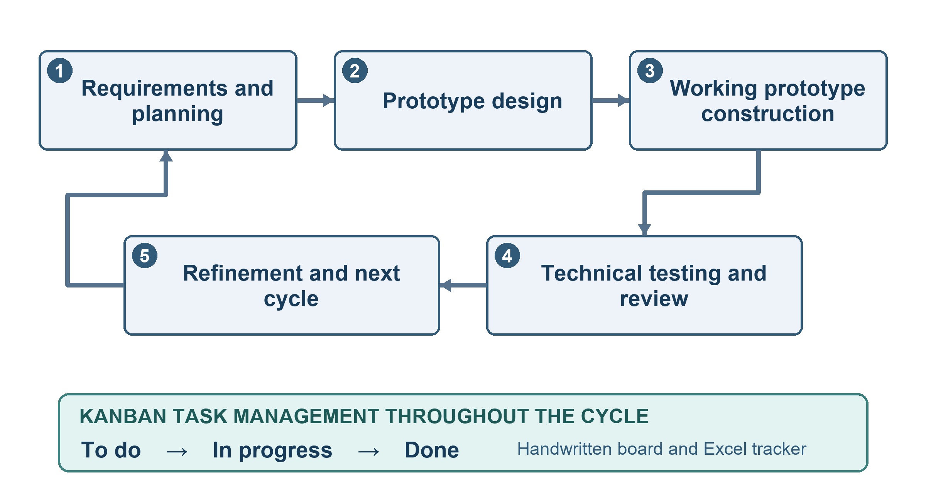
Figure 2. FloodSense Evolutionary Prototyping with Kanban
The study used developmental research with a descriptive needs-assessment phase. Developmental research guided the construction and refinement of the same FloodSense prototype; descriptive analysis summarized the responses of 40 purposively selected residents. Institutional interviews and document review informed requirements and data-governance boundaries. The initial survey investigated needs, not user experience with the prototype.
Evolutionary Prototyping organized software development into repeated requirements, design, construction, testing, and refinement work (Bjarnason et al., 2023). Kanban was integrated across those stages to visualize pending, active, and completed tasks on a handwritten board and in an Excel tracker (Microsoft, 2022). It was a task-management practice, not the research design or a separate software-development model. The team did not use fixed-length sprints, documented work-in-progress limits, throughput metrics, or Scrum ceremonies.
Requirements and planning
The approved concept and scope provided the starting requirements. A resident needs-assessment questionnaire was distributed through Google Forms and face-to-face collection. It covered flood experience, information sources and difficulties, preparedness needs, evacuation information, access and connectivity, and comfort with location sharing. Consented, recorded, and transcribed BDRRMO and CPDCO interviews and available documents informed institutional practices, source ownership, geographic information, and validation restrictions.
The researchers checked candidate requirements against the research questions, pre-event assessment scope, privacy and safety implications, available data, and technical feasibility. Survey answers and institutional suggestions were considered as requirements evidence rather than automatically converted into system functions. Tasks were recorded on the board and Excel tracker for development or further review.
Prototype design
The prototype was organized around access, rainfall-scenario and location input, deterministic susceptibility assessment, separate preparedness guidance, and administrative governance. The team prepared interface flows, data structures, service interactions, permissions, geographic behavior, and relevant test conditions. Design decisions were reconsidered when checks or domain feedback revealed a mismatch with the study boundaries or available evidence.
Working prototype construction
Two team members focused on software development and one on manuscript documentation, while helping across roles when needed. The resident application used Flutter; backend services, geographic processing, the REST API, and the custom administration interface used Django, Django REST Framework, GeoDjango, and PostgreSQL/PostGIS. GitHub was used to share and integrate work among the team, while the task board and Excel tracker showed work moving through the prototype stages.
The assessment flow processes a user-confirmed hypothetical rainfall scenario and location through deterministic rule matching and conflict handling. Structured Decision Support System guidance is separate from the susceptibility result. Resident access and administrative functions were built with role-appropriate controls. Technical implementation does not imply that provisional susceptibility information has received institutional approval.
Technical testing and review
The team manually checked functions after construction and refinement and used automated tests for supported mobile and backend behavior. Checks addressed authentication and permissions, input validation, scenario and location confirmation, rule matching, API and spatial responses, maps, preparedness guidance, evacuation-center lookup, administration, and mobile-to-service integration. Test outcomes support behavior under the tested conditions, not scientific validity, usability, institutional approval, or production readiness.
Developing work was reviewed at weekly adviser checkpoints. A BDRRMO prototype discussion provided domain comments on map interpretation, information sources, and validation needs. This was not a post-use resident evaluation or approval of demonstration susceptibility data. Findings and relevant suggestions were returned to the task board and Excel tracker for consideration in the next cycle.
Refinement and next cycle
The researchers addressed defects and relevant feedback within the established scope, refined the same prototype, and repeated applicable checks. This cycle allowed functions and requirements to be clarified without treating each prototype as a separate system. Future post-use testing with intended residents and BDRRMO representatives, a finalized feedback instrument, and any product-quality analysis will be undertaken only after the system and evaluation plan are ready; no post-use results are reported here.
Participants of the Study
Purposive sampling was used for the initial needs assessment. The analyzed dataset contained 40 qualified respondents who consented, were at least 18 years old, lived in Bacoor City, and had experienced flooding or serious heavy-rain effects. They represented 14 of the city’s 47 barangays. Niog contributed 13 respondents; Zapote I, II, and III contributed 15; and ten other barangays contributed 12. The concentration of 28 respondents (70.0%) in Niog and the Zapote barangays limits generalization beyond the participating sample. A response rate was not computed because a distribution denominator was not documented.
Thirty respondents (75.0%) were 18–34 years old. BDRRMO and CPDCO key informants contributed institutional requirements and data-governance context, not resident-user evaluation or evidence of system effectiveness. Participation was governed by the survey consent notice and interview-recording permission. Direct identifiers were excluded from the survey summary, and geographic responses were interpreted with care.
Table 4. Distribution of initial resident-survey respondents
RESPONDENT AREA | FREQUENCY | PERCENTAGE
Niog | 13 | 32.5%
Zapote I, II, and III | 15 | 37.5%
Other ten represented barangays | 12 | 30.0%
Total | 40 | 100.0%
Statistical Treatment of Data
The initial needs-assessment responses were summarized with frequencies and percentages. For multiple-response questions, each option used the 40 qualified respondents as its denominator, so option percentages could exceed 100% when added. The eight ordered information-problem items were also summarized by valid scored-answer means. Never, Rarely, Sometimes, Often, and Always were scored from 1 to 5; “Not sure” was retained in the frequency distribution but excluded from the mean for that item. No sample-size formula, response rate, or post-use system-evaluation score was calculated.
1. Percentage. The proportion selecting a response category or option was computed as follows:
The Formula is:
$$P = \frac{f}{N} × 100$$
Where:
P = percentage
f = number of respondents selecting the category or option
N = number of qualified respondents (40 for the reported survey items)
2. Item mean. The five-point information-problem responses were summarized as follows:
The Formula is:
$$M = \frac{Σ(fᵢ × xᵢ)}{Σfᵢ}$$
Where:
M = item mean
xᵢ = score from 1 to 5
fᵢ = frequency of that score
Σfᵢ = number of valid scored answers for the item; “Not sure” was excluded from this denominator.
Optional open comments were grouped by recurring information, map, location, preparedness, severity, and evacuation themes. Interview transcripts and documents were reviewed for institutional practices, provenance, validation, permissions, and system boundaries. These qualitative materials informed requirements; they were not treated as measured evidence of prototype effectiveness.
REFERENCES
Alsabhan, W., & Dudin, B. (2023). Real-time flood forecasting and warning: A comprehensive approach toward HCI-centric mobile app development. Multimodal Technologies and Interaction, 7(5), 44. https://doi.org/10.3390/mti7050044
Android Developers. (2026). Request location permissions. https://developer.android.com/develop/sensors-and-location/location/permissions
Bentoso, L. D., Juan, E. O., Brosas, D. G., Paragas, J. R., Nuevas, L. K., & Velarde, M. W. C. (2021). Web-based solution for flood warning decision support in the Province of Leyte, Philippines. In 2021 3rd International Conference on Research and Academic Community Services (ICRACOS) (pp. 185-190). IEEE. https://doi.org/10.1109/ICRACOS53680.2021.9701990
Bjarnason, E., Lang, F., & Mjöberg, A. (2023). An empirically based model of software prototyping: A mapping study and a multi-case study. Empirical Software Engineering, 28, Article 115. https://doi.org/10.1007/s10664-023-10331-w
Buchanan, B. G., & Shortliffe, E. H. (Eds.). (1984). Rule-based expert systems: The MYCIN experiments of the Stanford Heuristic Programming Project. Addison-Wesley.
Carpio, C. O., Asnaul, M. U., Said, A. H., & Amerin, B. Y. (2022). Isabela City flood monitoring system using Arduino and GSM module. International Journal of Multidisciplinary Research and Publications, 5(6), 13-17. https://ijmrap.com/wp-content/uploads/2022/11/IJMRAP-V5N5P134Y22.pdf
Copernicus Emergency Management Service. (2026). GloFAS homepage. European Centre for Medium-Range Weather Forecasts. https://confluence.ecmwf.int/spaces/CEMS/pages/315561239/3.1+GloFAS+homepage
Dela Cruz, C. A. V., Dela Cruz, J. R. L., Estolero, J. O., Lachica, B. J., Pineda, R. J. E., & Viduya, A. P. (2024). IOT-based flood alert system for Narvacan, Sto. Tomas, La Union [Unpublished undergraduate thesis]. Don Mariano Marcos Memorial State University-South La Union Campus. https://lakasa.dmmmsu.edu.ph/handle/123456789/117
Delos Reyes, D. C., Cabreros, R., Paulino, J. L., & Garcia, P. J. (2020). BantayBaha: Flood monitoring system with SMS notification. Tekne Portal, 7(1), 58-73. https://buresearch.baliuagu.edu.ph/storage/01K6Q692A27DH2FQZTDQ4M5Y45.pdf
Deltares. (2025, December 2). FloodAdapt. https://www.deltares.nl/en/software-and-data/products/floodadapt
Department of Science and Technology-Philippine Institute of Volcanology and Seismology. (2022a, December 6). DOST-PHIVOLCS conducts training on the use of GeoRiskPH platforms for the Municipality of General Luna, Quezon. GeoRisk Philippines Initiative. https://www.georisk.gov.ph/articles/2022/12/dost-phivolcs-conducts-training-on-the-use-of-georiskph-platforms-for-the-municipality-of-general-luna-quezon
Department of Science and Technology-Philippine Institute of Volcanology and Seismology. (2022b, September 28). DOST-PHIVOLCS conducts PlanSmart Ready to Rebuild training of trainers. GeoRisk Philippines Initiative. https://www.georisk.gov.ph/articles/2022/9/dost-phivolcs-conducts-plansmart-ready-to-rebuild-training-of-trainers
Environment Agency. (2024). National assessment of flood and coastal erosion risk in England 2024. GOV.UK. https://www.gov.uk/government/publications/national-assessment-of-flood-and-coastal-erosion-risk-in-england-2024/national-assessment-of-flood-and-coastal-erosion-risk-in-england-2024
Fakhruddin, B., Kirsch-Wood, J., Niyogi, D., Guoqing, L., Murray, V., & Frolova, N. (2022). Harnessing risk-informed data for disaster and climate resilience. Progress in Disaster Science, 16, 100254. https://doi.org/10.1016/j.pdisas.2022.100254
Federal Emergency Management Agency. (2025). Resilience Analysis and Planning Tool user guide. https://www.fema.gov/sites/default/files/documents/fema_rapt-user-guide_2025.pdf
Gacu, J. G., Monjardin, C. E. F., Senoro, D. B., & Tan, F. J. (2022). Flood risk assessment using GIS-based analytical hierarchy process in the Municipality of Odiongan, Romblon, Philippines. Applied Sciences, 12(19), 9456. https://doi.org/10.3390/app12199456
GeoRisk Philippines. (2023, August 3). DOST-PHIVOLCS' HazardHunterPH won a 7-Star Rating and the Category Award for Risk Management in the 9th International Best Practice Competition! https://www.georisk.gov.ph/articles/2023/8/dost-phivolcs-hazar-hunter-ph-won-a-7-star-rating-and-the-category-award-for-risk-management-in-the-9th-international-best-practice-competition
International Organization for Standardization. (2023). ISO/IEC 25010:2023 systems and software engineering - Systems and software Quality Requirements and Evaluation (SQuaRE) - Product quality model. https://www.iso.org/standard/78176.html
Iowa Flood Center. (2024). A strong purpose. IIHR Currents 2023-24. University of Iowa. https://iihr.uiowa.edu/news/iihr-currents/iihr-currents-2023-24/strong-purpose
Japan International Cooperation Agency. (2021, October 1). Flood risk protection project in Cavite inaugurated. https://www.jica.go.jp/english/overseas/philippine/information/press/2021/211001.html
Kostopoulos, G., Davrazos, G., & Kotsiantis, S. (2024). Explainable artificial intelligence-based decision support systems: A recent review. Electronics, 13(14), 2842. https://doi.org/10.3390/electronics13142842
Lagmay, A. M. F. A., Racoma, B. A., Aracan, K. A., Alconis-Ayco, J., & Saddi, I. L. (2017). Disseminating near-real-time hazards information and flood maps in the Philippines through Web-GIS. Journal of Environmental Sciences, 59, 13-23. https://doi.org/10.1016/j.jes.2017.03.014
Meléndez-Landaverde, E. R., & Sempere-Torres, D. (2023). A user experience evaluation of a mobile application for disseminating site-specific impact-based flood warnings: The A4alerts app. Journal of Flood Risk Management, e12951. https://doi.org/10.1111/jfr3.12951
Membele, G. M., Naidu, M., & Mutanga, O. (2022). Examining flood vulnerability mapping approaches in developing countries: A scoping review. International Journal of Disaster Risk Reduction, 69, 102766. https://doi.org/10.1016/j.ijdrr.2021.102766
Microsoft. (2022, November 28). What is Kanban? Microsoft Learn. https://learn.microsoft.com/en-us/devops/plan/what-is-kanban
Mostafiz, R. B., Rohli, R. V., Friedland, C. J., & Lee, Y.-C. (2022). Actionable information in flood risk communications and the potential for new web-based tools for long-term planning for individuals and community. Frontiers in Earth Science, 10, 840250. https://doi.org/10.3389/feart.2022.840250
Msusa, A. D., Deus, D., Nyalali, O. G., Gidudu, A., Wangabo, E., Makuti, S., & Marandu, G. (2025). Developing a climate-smart Web GIS app for multi-hazard early warning against climate-based disaster risks. The International Archives of the Photogrammetry, Remote Sensing and Spatial Information Sciences, XLVIII-4/W16-2025, 59-66. https://doi.org/10.5194/isprs-archives-XLVIII-4-W16-2025-59-2025
National Disaster Risk Reduction and Management Council. (2024). National disaster response plan 2024: Hydro-meteorological hazards. https://ndrrmc.gov.ph/attachments/article/4125/National_Disaster_Response_Plan_NDRP_2024.pdf
Papadopoulos, P., Soflano, M., Chaudy, Y., Adejo, W., & Connolly, T. M. (2022). A systematic review of technologies and standards used in the development of rule-based clinical decision support systems. Health and Technology, 12, 713-727. https://doi.org/10.1007/s12553-022-00672-9
Philippine Atmospheric, Geophysical and Astronomical Services Administration. (2024). 2023 annual climate bulletin. https://pubfiles.pagasa.dost.gov.ph/pagasaweb/files/cad/Climate%20Bulletin%202023_v5.pdf
Philippine Statistics Authority. (2023). Third quarter 2023 PSGC updates. https://psa.gov.ph/classification/psgc/node/1684061390
Philippine Statistics Authority. (2025). City of Bacoor: Barangays in the City of Bacoor. https://psa.gov.ph/classification/psgc/barangays/0402103000
Philippine Statistics Authority. (2026). Highlights of the Compendium of Philippine Environment Statistics 2016-2025, Component 4: Extreme events and disasters. https://psa.gov.ph/statistics/environment-statistics/highlights/component-4-extreme-events-and-disaster
PostGIS Development Group. (2026). PostGIS manual: Introduction. https://postgis.net/docs/manual-3.7/en/postgis_introduction.html
Power, D. J. (2002). Decision support systems: Concepts and resources for managers. Quorum Books.
Puno, G. R., Olpenda, A. S., Puno, R. C. C., Aguinsatan, R. G., Lacandula, L. F., Maghuyop, I. V., & Villar, R. G. (2022). GIS-based mapping of flashflood susceptible areas in Bukang Liwayway, Kibawe, Bukidnon. Central Mindanao University Journal of Science, 26(1), 19-29. https://doi.org/10.52751/bwyx7405
Republic Act No. 10173. (2012). Data Privacy Act of 2012. Republic of the Philippines. https://privacy.gov.ph/data-privacy-act/
Tullis, J. A., & Kar, B. (2021). Where is the provenance? Ethical replicability and reproducibility in GIScience and its critical applications. Annals of the American Association of Geographers, 111(5), 1318-1328. https://doi.org/10.1080/24694452.2020.1806029
Wisudawan, H. N. P. (2021). Design and implementation of real-time Flood Early Warning System (FEWS) based on IoT Blynk application. ELKHA: Jurnal Teknik Elektro, 13(2), 113-121. https://doi.org/10.26418/elkha.v13i2.49003
APPENDICES
Appendix A. FloodSense Fishbone Diagram
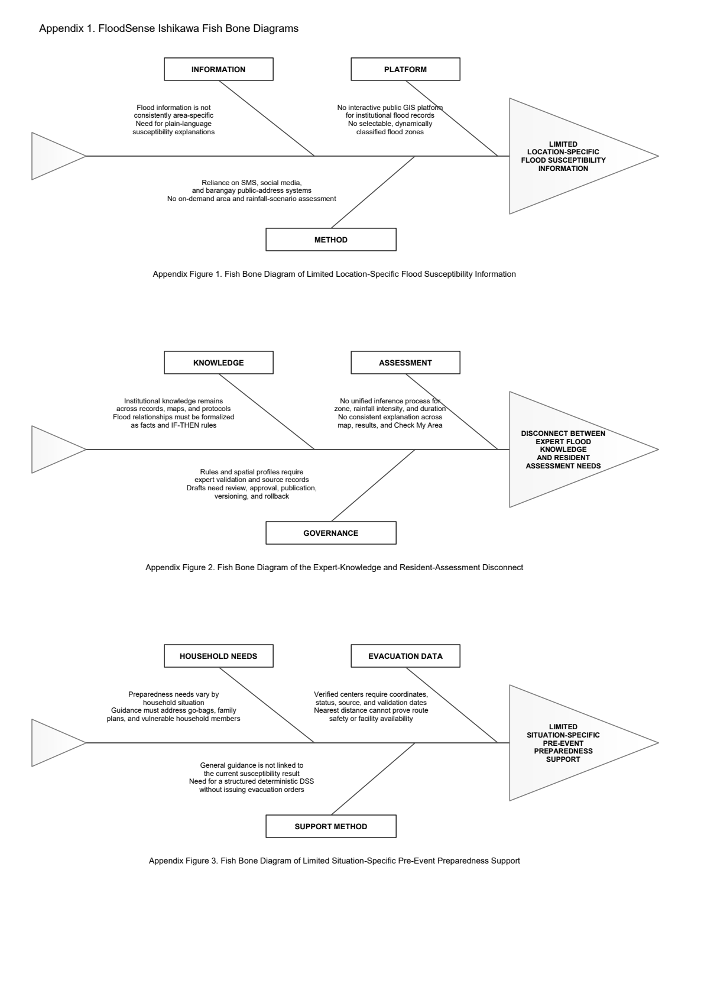
Appendix B. Resident Flood-Susceptibility Assessment Flowchart
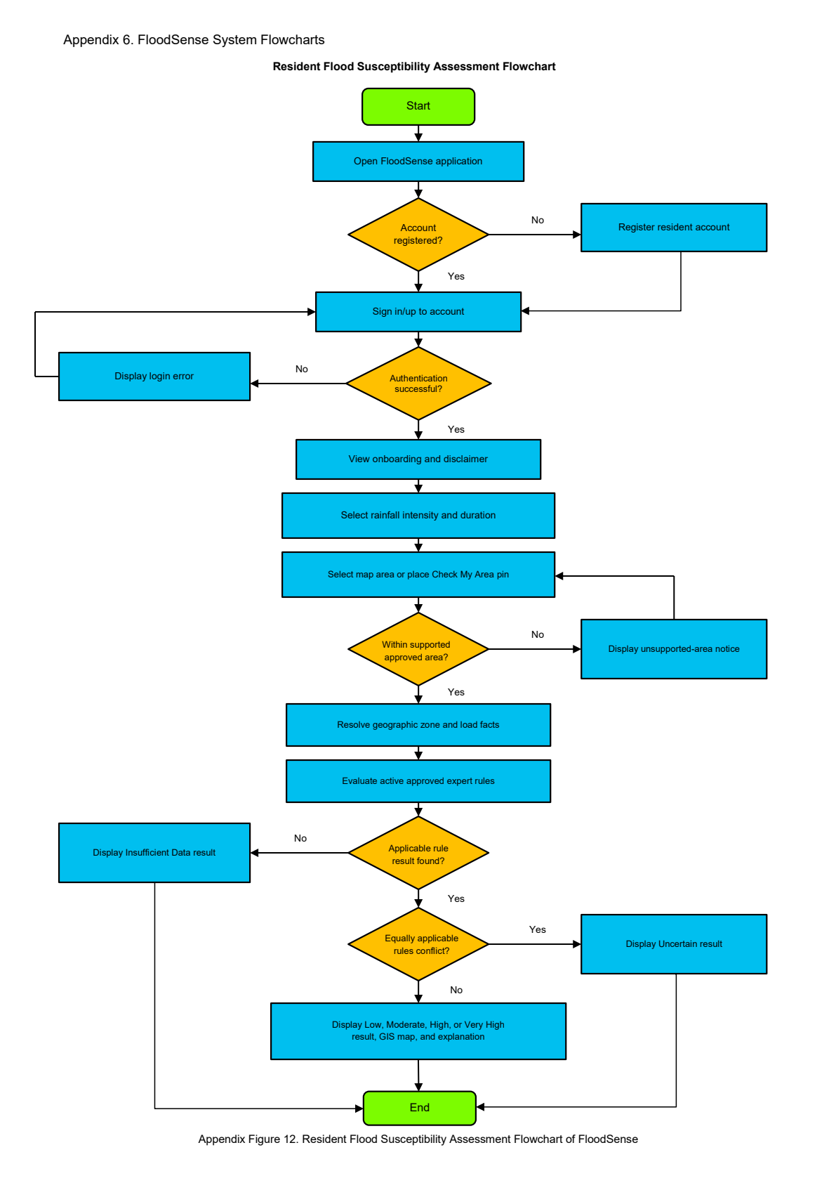
Appendix C. Resident Preparedness and Evacuation-Support Flowchart
